# Experiment 5: Implement a firewall for an organization.

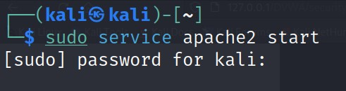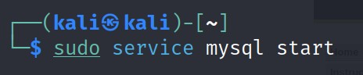

Check ip address in kali

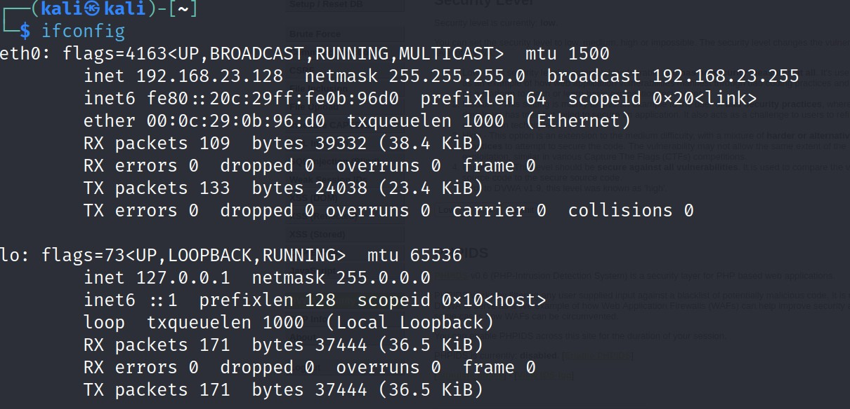

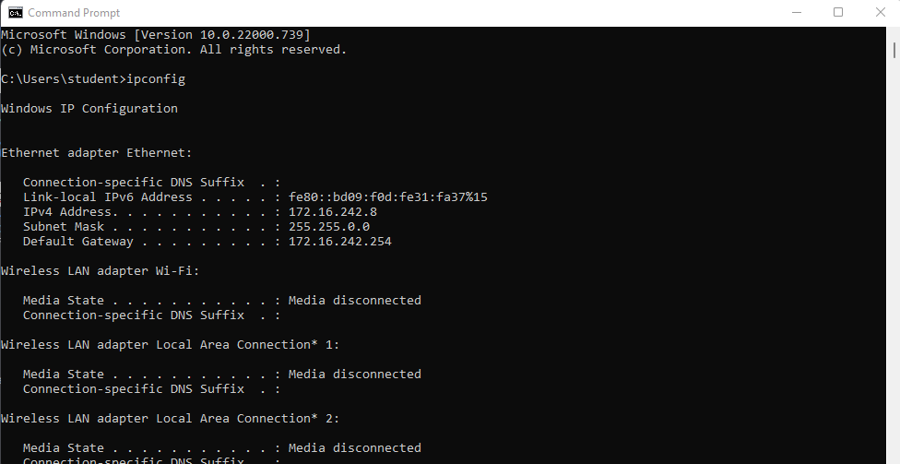Check ip address for windows in command prompt

Connect windows and kali using command prompt in windows

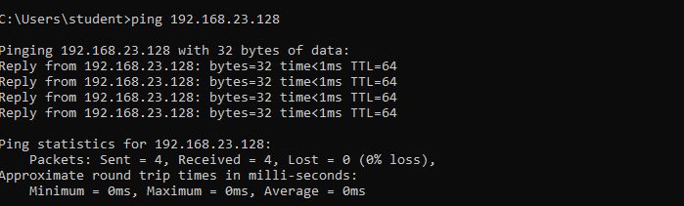

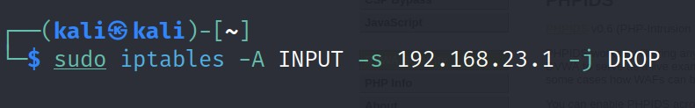To block pinging of windows system use the following command(should consider only IP address not ethernet’s address)

Now check whether ping requests are allowed in windows

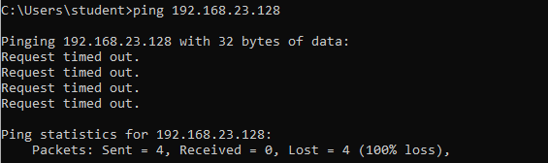

This way we can block ping packets.

# —--------------------------------------------------------------------------------------------------------------------------

To unblock the ping packets use the commands

Let’s check its unblocking the ping packets in the windows command prompt

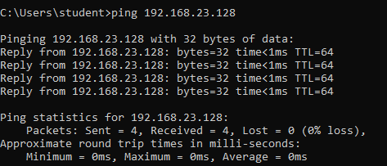

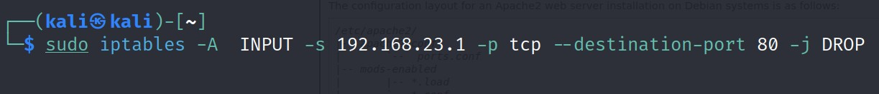— Task 2: Block the port numbers

Open browser in windows and search for its ip address in the address of kali linux bar – it opens the web page.

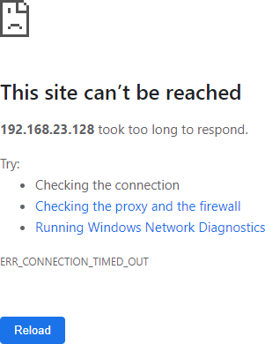

We need to block the availability of port 80. Instead of -A use -D

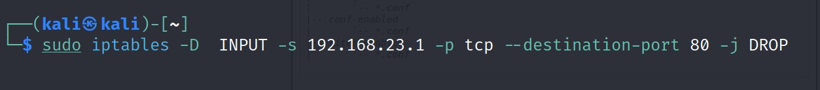

Now check the ip address of the kali linux in windows

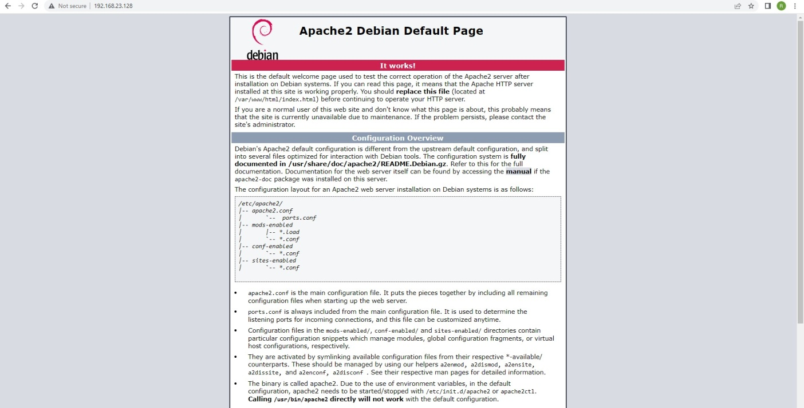**Result:**

Thus the implement a firewall for an organization completed suceessfuly.